**Practical:1**

**Aim:** **Design webpage using a simple HTML.**

**Practical 1.1: WAP in html containing following tag**

**- <h1 to h6></h1 to /h6>**

**- <p></p>**

**-<br> and <hr>**

**- &nbsp;**

**- <!-->**

**Program:**

<html>

<head>

<title> my first web programing </title>

</head>

<body bgcolor="lightpink">

<h1> This is heading 1</h1> <! -- tag is used to display a heading in our content -->

<h2> This is heading 2</h2>

<h3> This is heading 3</h3>

<h4> This is heading 4</h4>

<h5> This is heading 5</h5>

<h6> This is heading 6</h6>

<! -- paragraph tag -->

<p> my name is yash..i am student of RNGPIT.<! -- horizontal line tag --><hr><! -- break tag --><br> i like to do programing. <hr><br>my intrest in sevral field like web devlopment,machine learning,cloud computing,AL etc.</p>

<hr><p>i like to play many outdoor games like cricket, kabaddi,vollyball,kho-kho.</p>

<hr><p>i like to drive car and bikes.</p>

<hr><p> i like to watch web series and movies.</p><hr>

<p> i like to watch web series &nbsp; and movies.</p>

</body>

</html>

**Output:**

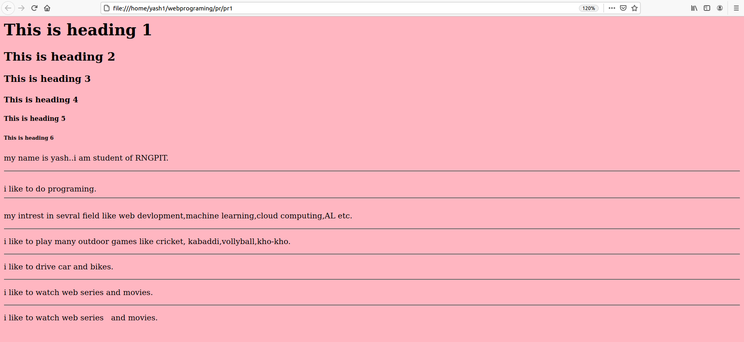

**Practical 1.2:** **WAP in html which demonstrate all the formatting tag.**

* **<b> - Bold text**
* **<strong> - Important text**
* **<i> - Italic text**
* **<em> - Emphasized text**
* **<mark> - Marked text**
* **<small> - Smaller text**
* **<del> - Deleted text**
* **<ins> - Inserted text**
* **<sub> - Subscript text**
* **<sup> - Superscript text**

**Program:**

<html>

<head>

<title> my first web programing </title>

</head>

<body bgcolor="lightgreen">

<h1> About india </h1>

<h1> About <del>india</del><ins>Hindustan</ins> </h1> <! --The HTML del element defines text that has been deleted from a document. Browsers will usually strike a line through deleted text -->

<! --The HTML ins element defines a text that has been inserted into a document. Browsers will usually underline inserted text: -->

<p>1. India is the world's largest democracy, with a 1.3 billion population. <i> It is also the world’s second largest country, after China’s 1.4 billion population.</i> </p>

<p>2. In the <strong>Hindu calendar</strong><! -- strong tag is used to display important text -->, there are six seasons or ritus: <b>vasant Ritu (spring), grishma ritu (summer), varsha ritu (monsoon), sharad ritu (autumn), hemant ritu (pre-winter), and shishir or shita Ritu (winter).</b> <! --The HTML b element defines bold text, without any extra importance.. --></p>

<p>3. <em>There are more than 19,500 languages or dialects spoken in India as mother tongues. </em> <! -- The HTML em tab element defines emphasized text. The content inside is typically displayed in italic. -->The country is one of the most diverse cultures on the planet with various regions corresponding to different languages and customs.</p>

<p>4.Indian cuisine, one of world’s best-known type of food, <mark> <sup>is said to be have six types of tastes: sweet (madhura), salty (lavana), sour (amala), pungent (katu), bitter (tikta) and astringent (kasya).</sup></mark></p> <! --The HTML sup element defines superscript text. Superscript text appears half a character above the normal line, and is sometimes rendered in a smaller font. -->

<P>5. In 2022, India plans to launch its first manned space mission. <mark>The Indian government announced it will allocate $1.4 billion for the proiect.</mark></p> <! --The HTML mark element defines text that should be marked or highlighted: -->

<P>6. The first Asian woman to win the <mark><sub>Miss World Competition </sub> </mark> <! --The HTML sub element defines subscript text. Subscript text appears half a character below the normal line, and is sometimes rendered in a smaller font.--> is from India. Reita Faria Powell, born in 1943 in Mumbai, is a model and doctor and won the beauty title in 1966</p>

<P>7. Most Indians don't watch Bollywood movies, according to the BBC. The country said to be obsessed with their grandiose musical productions has very few cinema screens -- 13,000 compared with about 40,000 screens in the United States.</p>

</body>

</html>

**Output:**

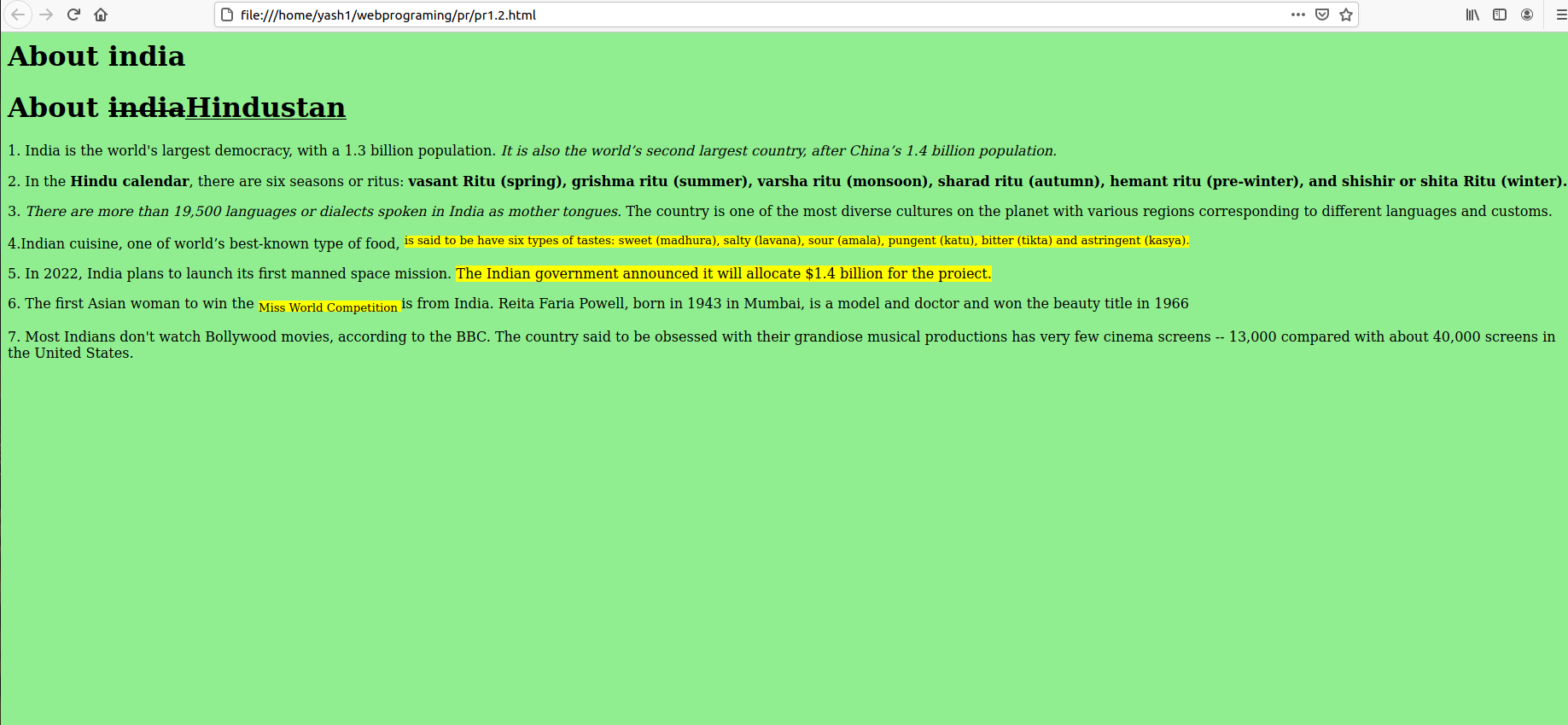

**Practical.1.3: WAP in html which demonstrate <font> tag.**

**Practical:**

<html>

<head>

<title> font tag</title>

</head>

<body bgcolor="yellow">

<h2>FONT TAGS PRACTICAL </h2>

<p>This is simple text line without any font using.</p>

<p><font color="red">In This line text with normal size abd default face.</font></p>

<p><font color="green"size="5">In This line text with increased size abd default face.</font></p>

<p><font color="blue"face="cursive"size="5">In This line text with changed face.</font></p>

</body>

</html>

**Output:**

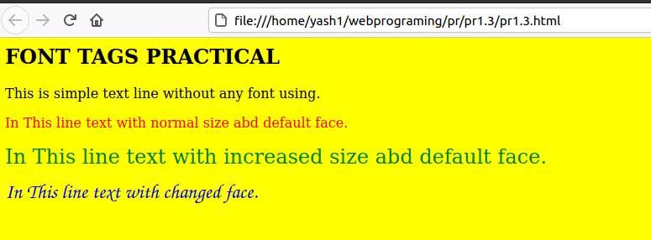

**Practical.1.4:** **WAP in html which demonstrate all types of List.**

**Program:**

<html>

<head>

<title> list type tag</title></head>

<body bgcolor="lightgreen">

<center><h1> list type </h1></center>

<p><mark color=>There are three types of list in html.<mark></p>

<ol>

<li>Ordered list or numbered list(ol)</li>

<li>UnOrdered list or bulleted list(ul)</li>

<li>description list or definition list(dl)</li>

</ol>

<h3>1.Ordered list</h3>

<ol>

<li>CRICKET</li>

<li>KABBADI</li>

<li>KHO-KHO</li>

</ol>

<h3>2.UnOrdered list</h3>

<ul>

<li>apple</li>

<li>mango</li>

<li>banana</li>

</ul>

<h3>3.Description list</h3>

<dl>

<dt>apple</dt>

<dd> apple is red.</dd>

<dt>mango</dt>

<dd> mango is green or yellow.</dd>

<dt>banana</dt>

<dd> banana is yellow.</dd>

</dl>

</body>

</html>

**Output:**

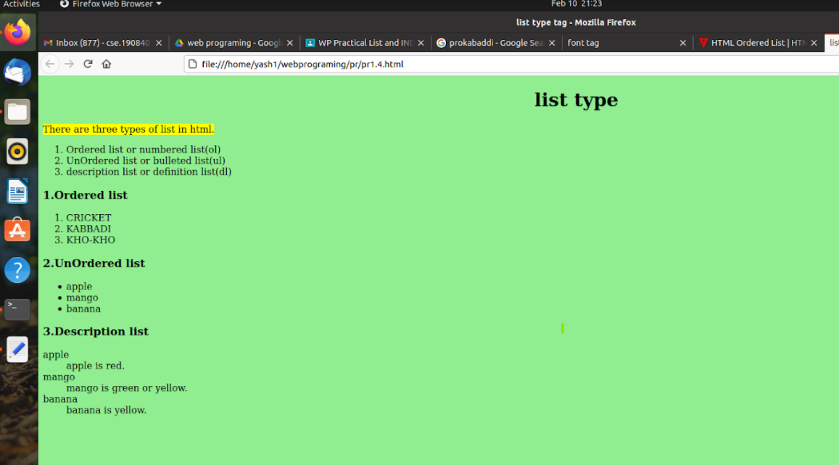

**Practical.1.5:** **WAP in html which demonstrates color and back ground facility.**

**Program:**

<html>

<head>

<title> color and bgcolor practical</title>

</head>

<body bgcolor="green">

<p><center><font color="white"size="10">Different domains in computer science field</center>

</font></p>

<p> <font color="yellow" size="5"><center>1.Artificial intelligence.</center></font></p>

<p><font color="black" size="5"><center>2.Computation & data security.</center></font></p>

<p><font color="blue" size="5"><center>3.Cloud computing.</center></font></p>

<p><font color="pink" size="5"><center>4.Data mining.</center></font></p>

<p><font color="lime" size="5"><center>5.Database security.</center></font></p>

<p><font color="brown" size="5"><center>6.Distributed Computing.</center></font></p>

<p><font color="darkblue" size="5"><center>7.Grid computing.</center></font></p>

<p><font color="purple" size="5"><center>8.Image processing.</center></font></p>

<p><font color="navy" size="5"><center>9.Distributed Networking.</center></font></p>

</body>

</html>

**Output:**

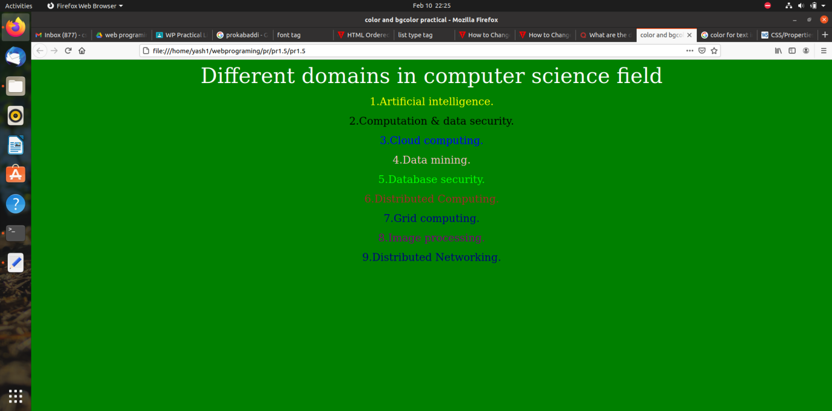

**Practical.1.6:** **WAP in html which demonstrate anchor tag andhref attribute to link up a page.**

**Program:**

<html>

<head>

<title> Anchor tag andhref attribute to link up a page.</title>

</head>

<body bgcolor="lightblue">

<p><font color="green"size="10">demonstrate anchor tag andhref attribute to link up a page.</p>

<p><font size"10"> click on <a href="https://www.google.com/" target="_blank"> This link </a>to go on google page.</p>

</body>

</html>

**Output:**

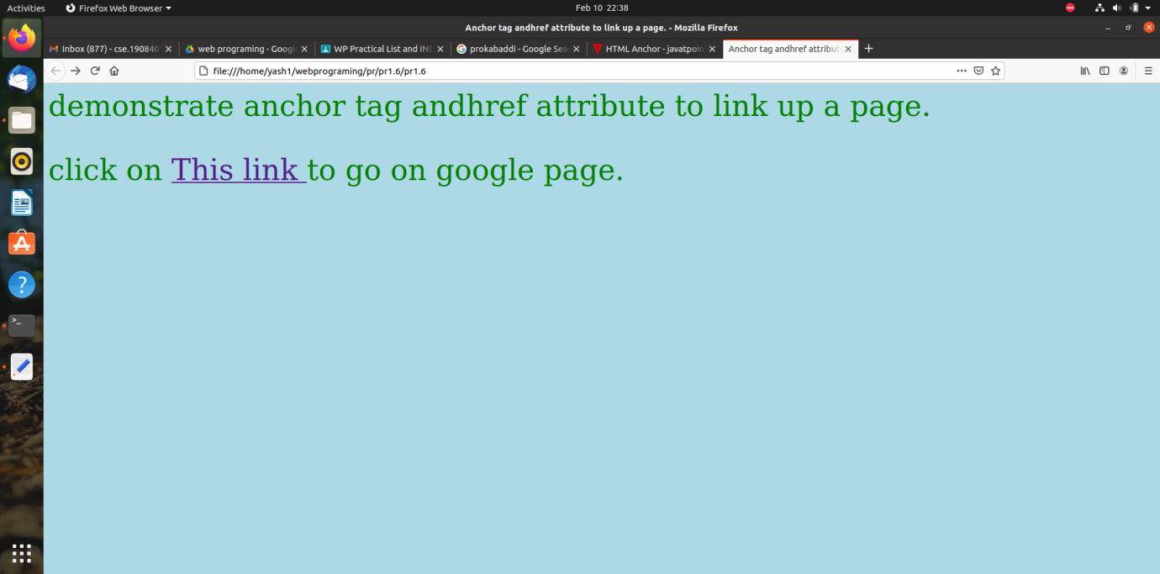

**Practical.1.7:** **WAP in html to demonstrate use of <img> and <area> tag.**

**Program:**

**Output:**

**Practical.1.8:** **WAP in html to demonstrate practical list document using fully<table>tag.**

**Program:**

<html>

<head>

<title> demonstrate practical list document using fully<table>tag.</title>

</head>

<body bgcolor="pink">

<mark><h1> Table</h1></mark>

<table border="3" bgcolor="yellow">

<tr>

<th> Practical no.</th>

<th> Name of Practical</th>

</tr>

<tr>

<td>1</td>

<td>Design webpage using a simple HTML.</td>

</tr>

<tr>

<td>2</td>

<td>Design HTML form for the Student registration application.</td>

</tr>

<tr>

<td>3</td>

<td>Design HTML Page using various tags of HTML5.</td>

</tr>

<tr>

<td>4</td>

<td>Develop HTML Page using CSS</td>

</tr>

<tr>

<td>5</td>

<td>Develop applications using JavaScript</td>

</tr>

<tr>

<td>6</td>

<td>Write programs using PHP</td>

</tr>

<tr>

<td>7</td>

<td>Develop applications using PHP and MYSQL</td>

</tr>

<tr>

<td>8</td>

<td>Write a program of hello world using jQuery and Ajax.</td>

</tr>

</table> </body> </html>

**Output:**

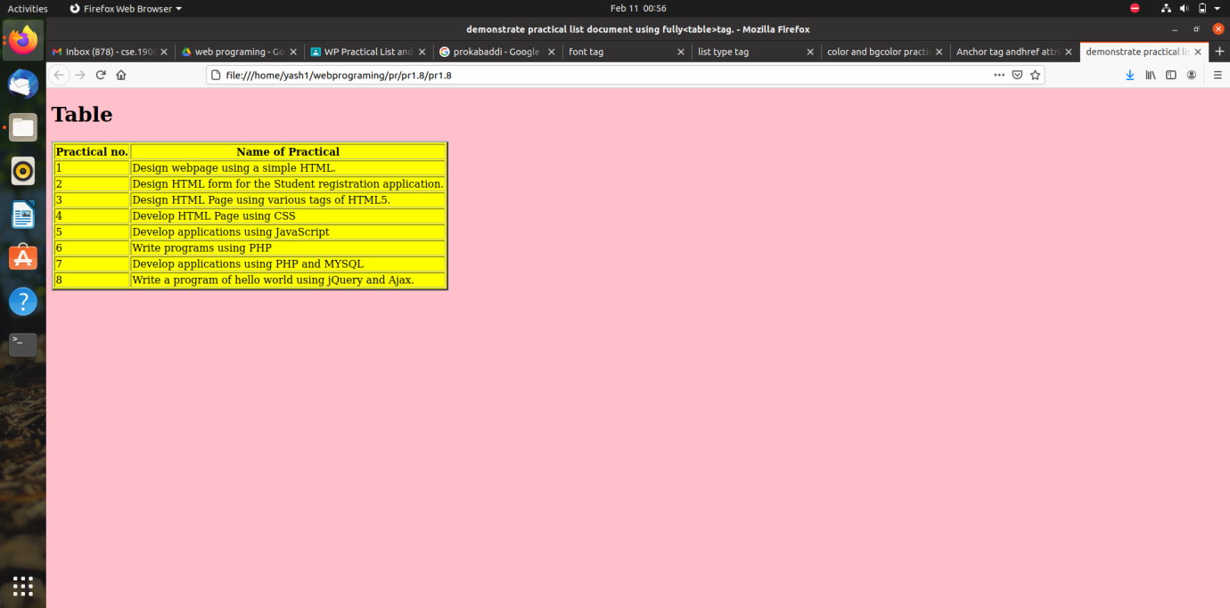

**Prcatical.1.9:WAP in html which demonstrate <frameset> <frame> <noframe> and <iframe>.**